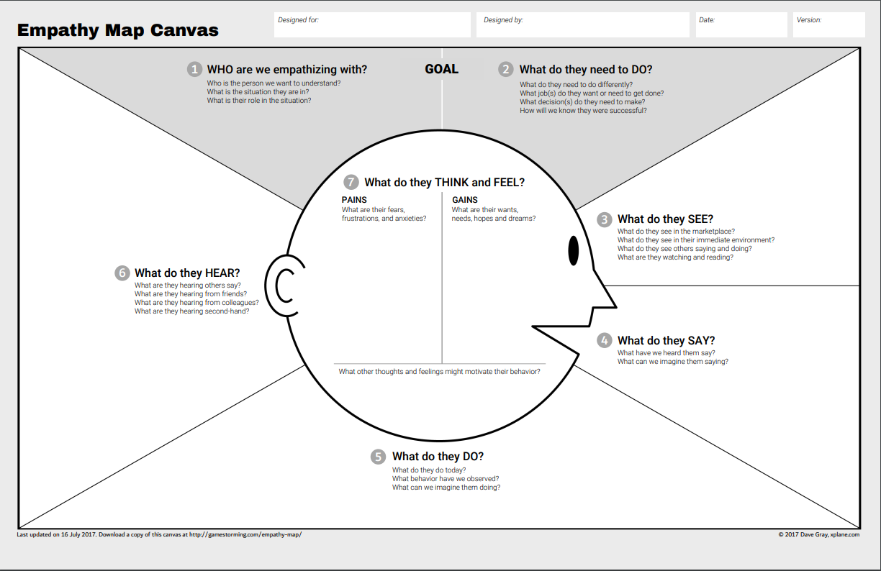

Think and Feel

Feel that the CMC is lacking

CMC should be improved

CMC is adequately performing

Empathy from the RM

Gains

* Decreased queue times
* Expert RMs associated to their desired holiday
* Acquiring a high score i.e. 8-10 leading to vastly decreased wait times as high rated customers are served first.

Pains

* Waiting for RM
* Being directed to an interactive voice response unit due to long wait queues
* Unknowingly acquiring low scores i.e. 1-3 causing longer wait times (customer favouritism

See

Travel Packages - Holiday, Other Promotions

The travel companies’ prices and compare it to their competition

RMs

Do

Learn the available packages and promotions

Confirm package information

Purchase holiday packages

Cancel holiday purchases

Say

Ask questions about the packages

Feedback to RMs

Complaining to the RMs

Explaining their circumstances

Hear

* The outcome of their explanation of their circumstances from the RM
* Other promotions from other travel companies
* The positive and the negative responses of the information system in the travel company
* The responses from the customers regarding the packages
* Reviews of the rating company from word of mouth

Customer



Say

Their wants and needs for the Information System

Thoughts/opinions on the system and feedback from developers

Think and Feel

How to improve the system

Believe the system is lacking

How to reduce the expenses

Gain

* Increased yearly revenue
* An increased repeated customer base
* Increase in business size
* Increase in customer satisfaction
* Increase in RM satisfaction

Pain

* Whether the money invested going to be worth it / a benefit that isn’t negligible or actually detrimental
* Maintenance after implementation (any issues, downtime)
* Decrease in customer satisfaction (dues to wait times from profiling)

Hear

Opinions from RMs and customers

Feedback from RMs and customers

What has been accomplished

What are the upcoming iterations

What cannot be accomplished

Updates from the developers and RMs

Do

Deciding the overall direction where the information system will lead

Altering requirements last minute

See

The system developers collecting the necessary requirements and information

Data of system i.e. profiles, ratings, RMs, etc

Owner



Gains

* Closing deals with customers

Relationship Manager

Pains

* The trouble with locating potential buyers
* Not able to close deals with clients
* Not able to perform sales effectively

Think and Feel

* System operating should be improved
* Feel that the system operating is lacking

Do

* Learn the available packages and promotions
* Perform sales to close deals with customers
* Meet with potential buyers

Say

* Encourage potential buyers to purchase

See

* Potential Customers
* Travel Packages - Holiday, Other Promotions

Hear

* Other promotions from other travel companies
* The positive and the negative responses of the operating system in the travel company
* The responses from the customers regarding the packages